References used in the project:

1. Hamel Village (From The Legend of Heroes : Trails of Cold Steel III)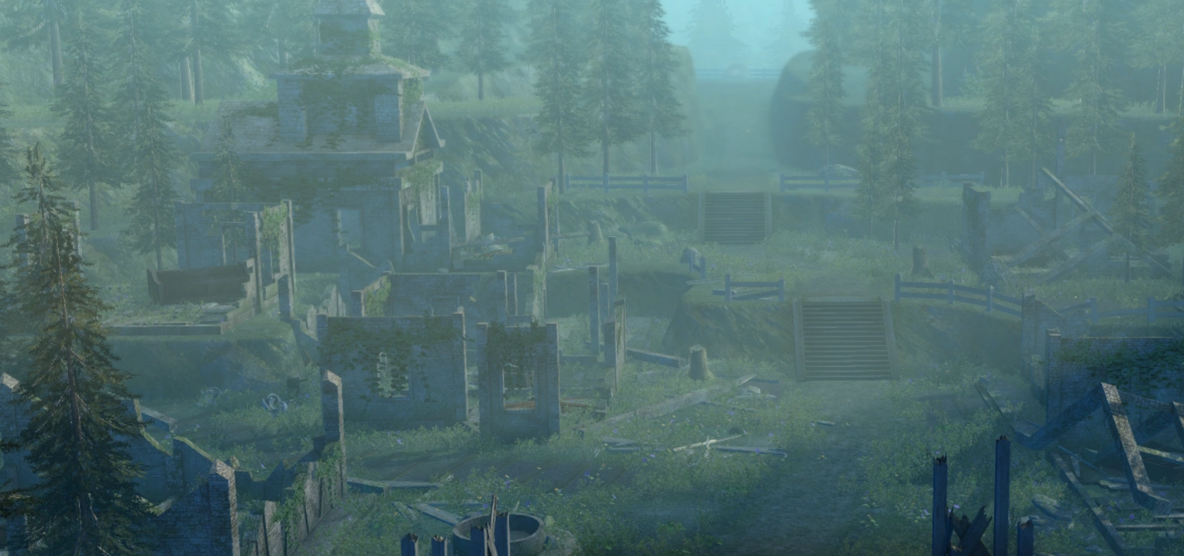

All rights reserved to Nihon Falcom Corporation

2. Sachsen Iron Mine (From The Legend of Heroes : Trails of Cold Steel I)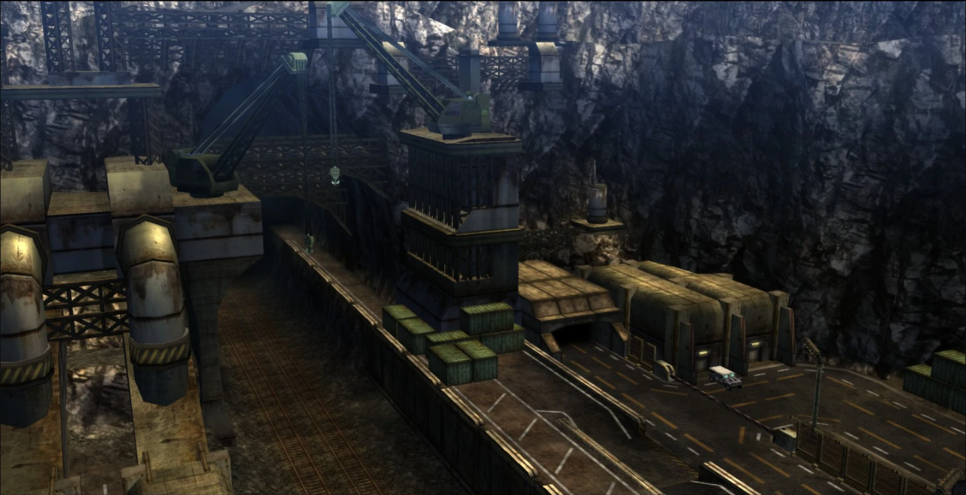

All rights reserved to Nihon Falcom Corporation

3. Racoon City (From Resident Evil 2)

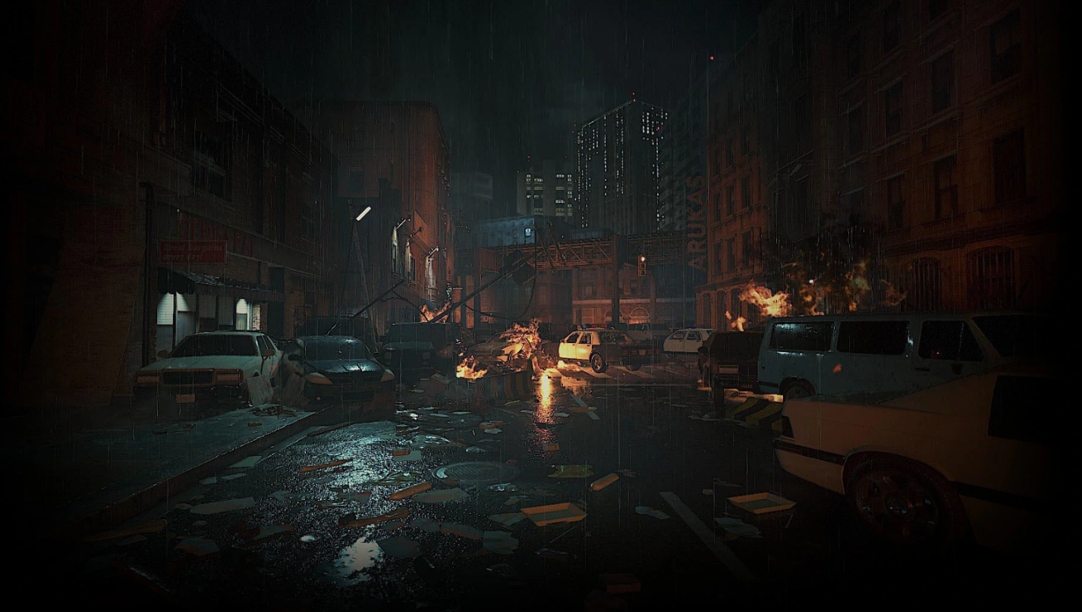

All rights reserved to Capcom Co. ,Ltd